[**Linux How to recover grub.conf password and remove kernel panic error**](http://computernetworkingnotes.com/system-administrations/grub.html)

The **Grand Unified Boo tloader (GRUB)** is a multiboot boot loader used for Linux With GRUB, users can select operating systems to run from a menu interface displayed when a system boots up. Use arrow keys to move to an entry and press ENTER.

As suggested by the Red Hat exam requirements, for the RHCT exam, you need to know how to use the GRUB menu to boot into different runlevels, and diagnose and correct boot failures arising from boot loader errors. We have covered how to boot system in different run level already in pervious article check that for run level related question.

In this article we will cover two most command booting issue. kernel panic error and grub password

**RHCE Exam Questions**

**You are giving RHCE exam. Examiner gave you the Boot related problem and told to you that make successfully boot the System. While booting system, you saw some error and stop the boot process by displaying some error messages.  
Kernel Panic - not syncing: Attempted to kill init!  
And no further boot process. What you will do to boot the system.**

If you are getting the Kernel panic error, it means it is boot loader related problem. Redhat Enterprise Linux uses the **GRUB boot loader**. You can pass the kernel parameter from the boot loader as well as you can correct the kernel parameter passing from boot loader from GRUB screen at boot time.

**RHEL Linux Kernel panic error**

For this practical we will modify **grub.conf** So you can understand what exactly case the kernel panic error.

always take back up before modifying **grub.conf** parameter

**#cp /etc/grub.conf /root**

**open /etc/grub.conf from vi command   
vi grub.conf  
Default grub.conf file look like this We suggest you to cram up this file   
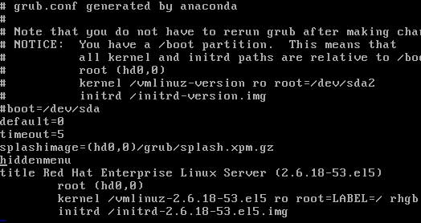  
Now change kernel line as show below [ change forward slash/ to backward slash\ ]  
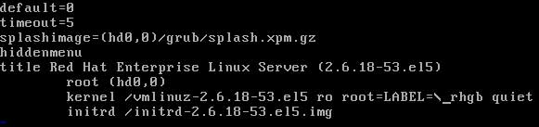  
Save file with :wq and reboot the system**

**On Restart you will get kernel panic error   
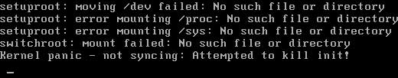**

**How to remove kernel panic error**

**Reboot system and press space bar on boot menu and select kernel line   
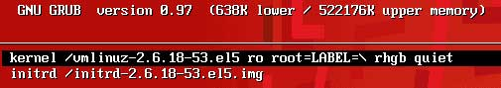  
Now press e for edit and you will see the wrong entry of kernel line in grub.conf   
  
Correct the kernel parameter replace backward slash\ to forward slash/ and press enter to save  
**

This will correct this error temporary.You will get same error after rebooting the system . As change here will not change the default faulty grub.conf so after booting system don't forget to Correct the kernel parameter replace backward slash \ to forward slash /

**#vi /etc/grub.conf**



**How remove grub.conf password**

By booting system in **single mode** one can easily recovered root password. This could case great security risk. For this every Linux system administrator password protect the **grub.conf** Two types of password can be set on grub.conf one to edit the parameter in **grub.conf** during boot process and another to boot operating system. But what if you lost both root and grub.conf password.

**For this practical open grub.conf file**

**#vi /etc/grub.conf**

**Set password for editing just below the hidemenu option and Set password for booting the OS just below the title menu  
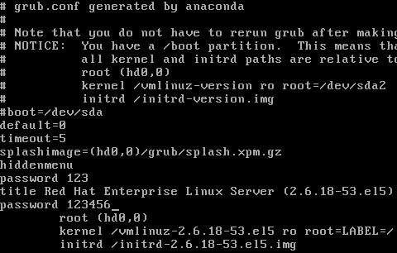  
Now save file with :wq and restart the system**

**Now press space bar on boot menu and press e to edit It will ask to give the password which you set below the hidemenu  
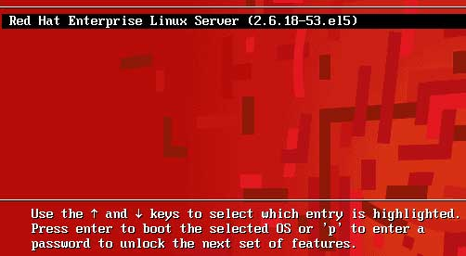  
After it on boot screen it will ask OS password which you set under the title menu   
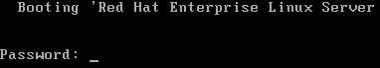**

Now assume that you lost all three **root, grub.conf** and **boot loader** password. How will you recover these passwords.

**Boot system from Linux CD and give linux rescue command on boot screen   
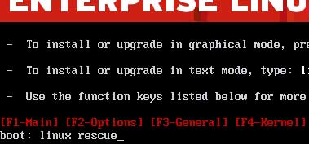  
Select language to English   
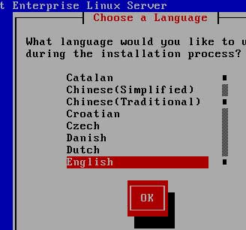  
Select Keyboard layout to US   
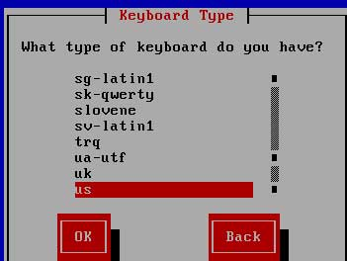  
Press enter on continue and it will search for linux on hard disk  
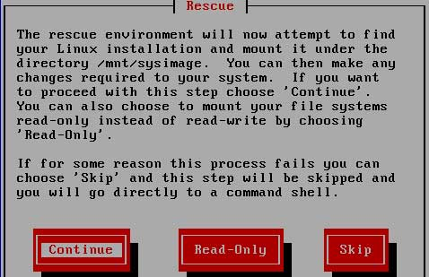  
We don't need networking for this operation so select no   
  
Rescue mode will mount system image under the/mnt/sysimage folder press ok**

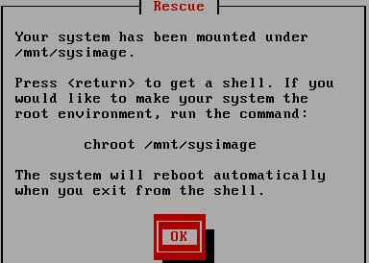

**now change chroot to/mnt/sysimage and open/etc/grub.conf  
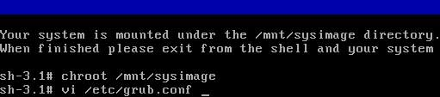  
Remove both hidemenu and title password and save file   
  
Now reboot the system and remove Linux CD from CDROM  
http://computernetworkingnotes.com/images/rhce_certification/image/ass47_sh_reboot.jpg**

**After reboot there should be no password onOS selection screen   
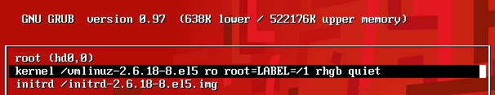  
And on boot screen  
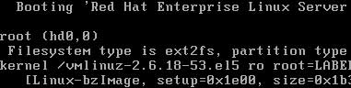**

We have recovered both boot loader and OS selection menu password now you easily recovered **root password** by booting system in single mode.